# Kennesaw State University

College of Computing and Software Engineering

Department of Computer Science

CS 5070, Mathematical Structures for Computer Science, Section W01

Assignment #3

Amrit Singh, [asingh59@students.kennesaw.edu](mailto:asingh59@students.kennesaw.edu)

06/25/2025

## Problem Statement

Problem of this document is to solve the following problem set for assignment #2.

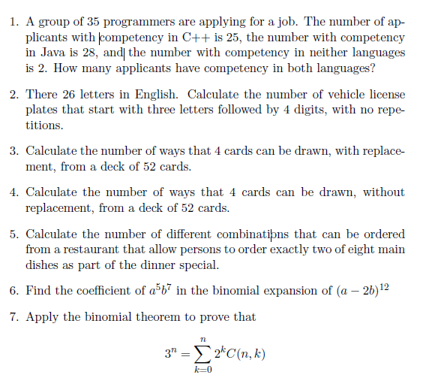

## Summary / Purpose

Purpose of this document is to provide solutions to the problem set outlined in the Problem Statement section.

## Solutions

1. A group of 35 programmers are applying for a job. The number of applicants with competency in C++ is 25, the number with competency in Java is 28, and the number with competency in neither languages is 2. How many applicants have competency in both languages?

Suppose *A* is the set of all applicants that are competent in C++ and *B* is the set of all applicants that are competent in Java. We can say that the cardinality of *A* ($|A|$), is the number of applicants that are competent in C++ and the cardinality of *B*, $|B|$, is the number of applicants that are competent in Java. Hence,

$$\left|A\right|=25$$

$$\left|B\right|=28$$

We can also say that the cardinality union of the two sets, $\left|A∪B\right|$ is the number of students that can be competent in either language. We know 2 of these students are not competent in neither language. So thus,

$$\left|A∪B\right|=35-2=33$$

Using the cardinality of a union equation of 2 sets, we can then find the cardinality of the intersection of the sets $|A∩B|$, aka the number of applicants that are competent in both languages by:

$$\left|A∪B\right|=\left|A\right|+\left|B\right|-\left|A∩B\right|=33=25+28- \left|A∩B\right|$$

$$\left|A∩B\right|=25+28-33$$

$$\left|A∩B\right|=20$$

1. There are 26 letters in English. Calculate the number of vehicle license plates that start with three letters followed by 4 digits, with no repetitions.

We have 26 letters in English and can also choose from 10 digits (from 0 – 9). The license plate starts with 3 letters, followed by 4 digits so we have 7 events in total. There must be no repetitions, therefore, as we choose either a letter or digit, we must remove one from each respective pool.

Suppose *P(l, m)* is permutation of k letters and *P(d, n)* is the permutation of *m* digits, so:

$$P\left(n, k\right)=P\left(l, m\right)*P\left(d, n\right)=$$

$$\frac{l!}{\left(l-m\right)!}*\frac{d!}{\left(d-n\right)!}=$$

$$\frac{26!}{\left(26-3\right)!}*\frac{10!}{\left(10-4\right)!}=$$

$$\left(26*25*24\right)*\left(10*9*7\right)= 78,624, 000$$

We have 78,624,000 choices of licenses plates.

1. Calculate the number of ways that 4 cards can be drawn, with replacement (repetition), from a deck of 52 cards.

A 2 3 4 5 6 7 8 9 10 J Q K = 13 * 4 = 52

We have 52 cards to choose from, 13 cards from each suit, and need to draw 4. Picking cards to be drawn from will change hands, so order does matter and we’re also told that we can repeat. Each card can be selected 52 ways and there’s 4 draws. Therefore, we have *P(n, k)* = nk =524 = 7,311,616 ways of a selecting those draws.

1. Calculate the number of ways that 4 cards can be drawn, without replacement (repetition), from a deck of 52 cards.

We have 52 cards to choose from, 13 cards from each suit, and need to draw 4. Picking cards will reduce the pool of cards to choose from. Order matters, and we can’t repeat. Therefore, we have

$$P\left(n, k\right)=$$

$$\frac{n!}{\left(n-k\right)!}= \frac{52!}{\left(52-4\right)!}=52*51*50*49= 6,497,400$$

We have 6,497,400 ways of selecting those draws.

1. Calculate the number of different combinations that can be ordered from a restaurant that allow persons to order exactly two of eight main dishes as part of the dinner special.

We’re told that there are 8 main dishes, and a customer can order exactly 2 of them in any combination. Assuming there are 8 distinct choices, we know that order does not matter and there are no repeats. Thus:

$$C\left(n,k\right)= \left({n \atop k}\right)=\frac{n!}{\left(n-k\right)!k!}=$$

$$C\left(8, 2\right)= \left({8 \atop 2}\right)=\frac{8!}{\left(8-2\right)!8!}=$$

$$\frac{8*7*6*5*4*3*2*1}{\left(6*5*4*3*2*1\right)(2*1)}= \frac{8*7}{2*1}= \frac{56}{2}=28$$

We have 28 choices to choose from.

1. Find the coefficient of $a^{5}b^{7}$ in the binomial expansion of ${\left(a-2b\right)}^{12}$

Using pascal’s triangle below,

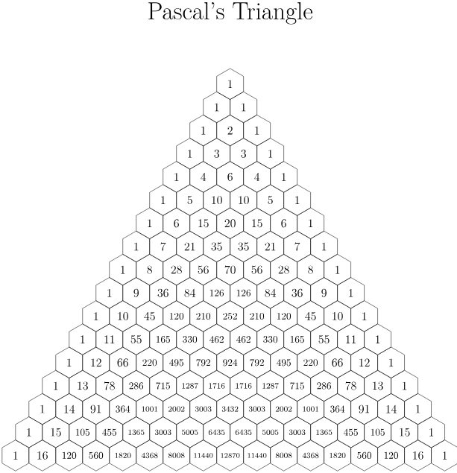

We can see that that this binomial will expand to this part of the triangle:



There fore we can deduce that

$${\left(a-2b\right)}^{12}=1a^{12}-12a^{11}{\left(2b\right)}^{1}-66a^{10}{\left(2b\right)}^{2}….- 792a^{5}{\left(2b\right)}^{7}…+{\left(2b\right)}^{12}$$

Therefore, the coefficient for $a^{5}b^{7}$ is -792*27 = -101,376.

1. Appy the binomial theorem to prove that:

$$3^{n}= \sum_{k=0}^{n}{2^{k}C(n, k)}$$

The binomial theorem stipulates that:

$${\left(x+y\right)}^{n}= \sum_{k=0}^{n}{x^{n-k}y^{k}* C(n, k)}$$

So in order for the following:

$$\sum_{k=0}^{n}{2^{k}C(n, k)}= \sum_{k=0}^{n}{x^{n-k}y^{k}* C(n, k)}$$

We need xn-k be equal to 1 and yk = 2k, therefore x = 1 and y = 2. Hence,

$$\sum_{k=0}^{n}{{(1)}^{n-k}{(2)}^{k}* C(n, k)}={\left(1+2\right)}^{n}=3^{n}$$

## References

[1] Garrido, J. (2021, August 14). *CS5070 Mathematical Structures for Computer Science - Notes 3* [Slide show; Powerpoint]. D2L. https://kennesaw.view.usg.edu/d2l/le/content/3550928/viewContent/55786714/View

[2] Garrido, J. (2022, May). *CS5070 Mathematical Structures for Computer Science - Notes 3b* [Slide show; Powerpoint]. D2L. https://kennesaw.view.usg.edu/d2l/le/content/3550928/viewContent/55786715/View

[3] Kennesaw State University, College of Computing and Software Engineering, Department of Computer Science, Mathematical Structures for Computer Science. (n.d.). CS5070 Assignment 3. In *https://kennesaw.view.usg.edu/d2l/le/dropbox/3550928/3805269/DownloadAttachment?fid=184379319*.

[4] Levin, O. (2016). *Discrete mathematics: An Open Introduction*.